

Faculty of Information Technology

Media Technologies.

**Web development midterm (group project).**

**Document of university’s canteen.**

Prepared by Zhansaya Turarova,

Nazira Kadyrova,

Aruzhan Tumabekova,

Ademi Jumaniyazova,

Aida Gaziz.

Group: MT-2001

Professor: Aldiyar Salkenov.

Nur-Sultan, 2021

Context

**1. Overview** 3

**1.1 About your team** 3

**1.2 Members and their roles** 4

**1.3 Communication strategy** 4

**1.3.1 Meetings and brainstorming minutes** 4

**1.4 Motivation** 4

**1.5 High-level project scope** 5

**1.6 Target audience/market** 5

**2. Project goals and team interests** 5

**2.1 Project goals** 5

**2.2 Team interests** 6

**3. Phases** 6

**4. Content structure** 7

**4.1 Site map** 7

**4.2 Content types** 8

**4.3 Design** 8

**4.3.1 Design assets** 8

**4.3.2 Style guide** 11

**4.4 Functionality** 12

**4.4.1 Homepage** 12

**4.4.2 Menu** 13

**4.4.2.1 Breakfast section** 13

**4.4.2.2 Salads section** 14

**4.4.2.3 Lunch section** 15

**4.4.2.4 Drinks section** 16

**4.4.3 Reservation** 17

**4.4.4 Contact** 18

**4.5 Hosting** 18

**4.5.1 Software requirements** 18

**4.5.2 Hardware requirements** 18

**4.5.3 Technical specification (minimum specifics):** 19

**4.5.4 General guide of implementing GitHub** 19

**4.6 Accessibility** 22

**4.7 Deadlines** 24

**5. Summary** 25

**6. References** 26

# **1. Overview**

## **1.1 About your team**

Our team, named “Garyshker” consists of 5 people: Zhansaya Turarova, Nazira Kadyrova, Ademi Jumaniyaziva, Aida Gaziz, between whom responsibilities of projects were equally subdivided. Overall, our team did not experienced bold conflicts regarding the assignment; however, we have been able to negotiate some differences in project’s vision and come to a unit idea of what our project will look like. Generally, the workload of creating a website has been distributed equally among group members.

## **1.2 Members and their roles**

To provide a precise representation of what each member of the group have been doing, it was decided to create a table.

* Zhansaya Turarova (id:201011, email: [201011@astanait.edu.kz](mailto:201011@astanait.edu.kz));
* Nazira Kadyrova (id:201436, email: [201436@astanait.edu.kz](mailto:201436@astanait.edu.kz));
* Aruzhan Tumabekova (id:201101, email: [201101@astanait.edu.kz](mailto:201101@astanait.edu.kz));
* Ademi Jumaniyazova (id:201304, email: [201304@astanait.edu.kz](mailto:201304@astanait.edu.kz));
* Aida Gaziz (id:201435, email: [201435@astanait.edu.kz](mailto:201435@astanait.edu.kz)).

|  |  |  |  |
| --- | --- | --- | --- |
| Student name | Student id | Student email | Role |
| Zhansaya Turarova | 201011 | [201011@astanait.edu.kz](mailto:201011@astanait.edu.kz) | Reservation (booking system via MailChimp) |
| Nazira Kadyrova | 201436 | [201436@astanait.edu.kz](mailto:201436@astanait.edu.kz) | Homepage |
| Aruzhan Tumabekova | 201101 | [201101@astanait.edu.kz](mailto:201101@astanait.edu.kz) | Footer and context of the documentation |
| Ademi Jumaniyazova | 201304 | [201304@astanait.edu.kz](mailto:201304@astanait.edu.kz) | Menu |
| Aida Gaziz | 201435 | [201435@astanait.edu.kz](mailto:201435@astanait.edu.kz) | Menu |

*Figure 1.1- table “roles of group member”.*

The figure above displays a table, which consists of following attributes: student’s name, id, email and its role (contribution) in the teamwork.

Since the menu is the biggest part of a project, it was decided that 2 people will work on it, to be more precise Aida and Ademi worked together in order to create a menu. Secondly, Nazira was responsible for setting the homepage, including the navigation bar. Next, Zhansaya’s duty was to implement an interactive booking system via the Mailchimp. Finally, Aruzhan’s scope was to create a footer and create a report for the project.

## **1.3 Communication strategy**

### **1.3.1 Meetings and brainstorming minutes**

Throughout a week, it was decided that it would be much more efficient if the group will arrange meetings on a daily basis in the university. The university facilities provided all necessary tools that were invaluable in adjusting of working environment. In the beginning of every meeting the brainstorming process was established and we set an agenda for every meeting.

## **1.4 Motivation**

Our project solves many problems that canteen staff and clients have encountered. For example, with a visual representation of menu, it is become much more easier for clients to depict what meal will look like. Then, this website also combats with the issue of long queues. Since the website has an ultimate booking system, there will be no more crowd of people in an extremely small area. Thirdly, as it was mentioned above, a long queue is commonly occurred in the canteen, which violates the anti-coronavirus regulations. Since the website consists of a reservation system, the massive influx of people will be no longer a problem.

## **1.5 High-level project scope**

After the group discussions, it was decided that creating a brand-new website would satisfy all of our demands. Fixing the existed website by making alterations in webpages could cause more problems rather than starting over. Hence, we decided to create a new website without any pattern. Although some pieces of code were borrowed from Bootstrap, we adjusted it; so that it would be suitable for our own website

## **1.6 Target audience/market**

The website is targeted at a broad audience that includes potential clients (students, faculty staff, and employees) and canteen staff. Moreover, this website has been elaborated for all possible clients, so that they could scroll over the canteen’s menu, book a place and get in touch with the canteen itself, if it is necessary. Furthermore, the site enables the canteen staff to track the queue: what is available and what is booked.

# **2. Project goals and team interests**

# **2.1 Project goals**

During the first group meeting, the project goals were determined and formulated as follows:

* To create a user-friendly interface which will be convenient to implement by potential clients and employees.
* To create a booking system which enables potential clients to reserve their place in a queue.
* To create an appealing meal menu for the canteen.
* To create a convenient navigation bar which points out all necessary sections of the website.
* To create a webpage that is dedicated to meal menu which will include sections, such as drinks, breakfast, lunch and salads.
* To create an appealing footer, consisting of contact information of the canteen.

## **2.2 Team interests**

Based on group negotiations, team interests were created:

* To consolidate HTML and CSS knowledge.
* To obtain Bootstrap skills.
* To align food items using Bootstrap layout grid.
* To show a solid understanding of website design principles.
* To boost communication skills among peers.
* To learn how to negotiate while collaborating with members of the group.

# **3. Phases**

Overall, it can be clearly seen that website creation took 8 phases to carry out in order to complete it.

* Phase 1 – Basic skeleton/prototype to determine how website will look like and what pages it will consist of.
* Phase 2 – Determine what are the input, output forms and what information they will require.
* Phase 3 – Selection of fonts, font-families, images, icons that will be on a future website.
* Phase 4 – Creation of a basic layout for the website in HTML.
* Phase 5 – Addition of styles by linking the HTML document with external css file.
* Phase 6 – Enhancing design of a website by adding Bootstrap grid.
* Phase 7 – Uploading the website on a GitHub platform.
* Phase 8 – Writing report documentation, regarding the website project.

# **4. Content structure**

## **4.1 Site map**

In order to create a vision of the website, a site map was carried out. This diagram enables users to show a skeleton of the website by showing which webpages does it have.

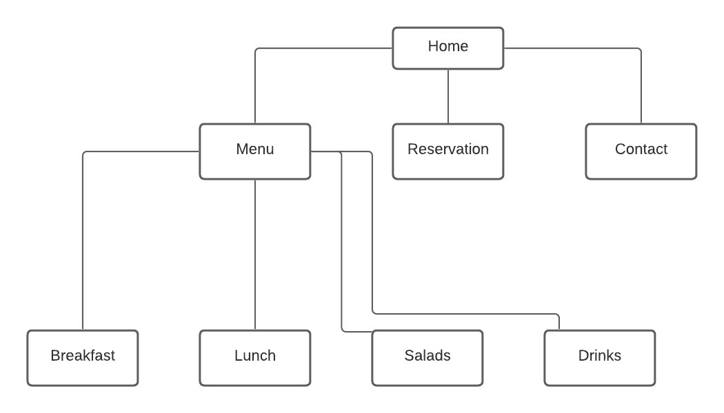

Figure 4.1 – site map of the website.

The figure above shows the site map of the website. From the diagram it can be perceived that there is a main webpage, named “Home” from which user can access to further webpages. Then, there is a navigation bar in the homepage, which consists of links to menu, reservation and contact webpages. Finally, the menu page has links to breakfast, lunch, salads and drinks.

## **4.2 Content types**

There were some several content types in the website, which can be summarized as follows:

* Text/css is used to connect the html file with external css file which consists of styles.
* Image/jpeg is used to embed a picture of format jpeg to the website.
* Image/png is used to embed a picture of format png to the website.
* Text/html is used to define a text in html document
* Meta charset UTF-8 specifies the character encoding for html document

## **4.3 Design**

### **4.3.1 Design assets**

Reference links:

* Bootstrap CSS – connecting website to Bootstrap CSS.

<link rel="stylesheet" href=<https://stackpath.bootstrapcdn.com/bootstrap/4.4.1/css/bootstrap.min.css>

/>

* Bootstrap Js – connecting website to Bootstrap JS.

<script src="https://code.jquery.com/jquery-3.4.1.slim.min.js"></script>

<script src="https://cdn.jsdelivr.net/npm/popper.js@1.16.0/dist/umd/popper.min.js"></script>

<script src="https://stackpath.bootstrapcdn.com/bootstrap/4.4.1/js/bootstrap.min.js"></script>

* My CSS – connecting website to external css file with styles.

<link rel="stylesheet" href="main.css"/>

* Font Awesome – connecting website to implement icons from Font Awesome.

<script src="https://kit.fontawesome.com/996973c893.js"></script>

* Google Fonts – connecting website to Google fonts so that the texts in the website will be with that font.

<link rel="preconnect" href="https://fonts.gstatic.com">

<link href="https://fonts.googleapis.com/css2?family=Inconsolata:wght@200;400;500;700&display=swap" rel="stylesheet">

Image files:

* Image files were found across the internet, and main requirement was to look for high quality and appealing image with no background on it.
* Most of the pictures were borrowed from website Koktem (<https://cafekoktem.kz/> )

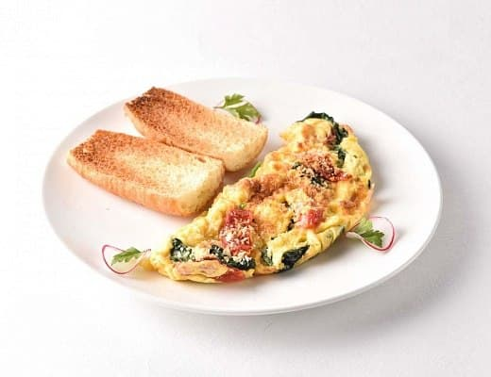Common examples are:

*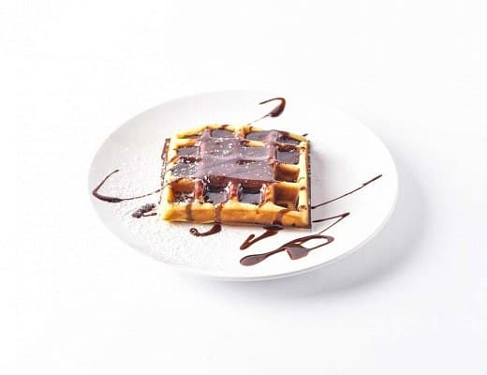Figure 4.3.1- menu of the canteen.*

The figure above illustrates the examples of images that were used in the website as a menu for a canteen.

Sketch files:

The images for discounts and business lunches were created on our own. To sketch the illustration, the Figma application software has been installed.

Common examples:



*Figure 4.3.2- discount card of the canteen.*

The figure above illustrates the discount card of the canteen which was placed in the carousel in the homepage. The card has been sketched on the Figma application software.

## **4.3.2 Style guide**

* Colours:

#7bbd37 (green)

#d2613d (red)

#802989 (violet)

#001737 (space blue)

* Typography rules:

1. Select fonts (link to Google font).
2. Select icons from Font Awesome (link to Font Awesome).
3. Modify the font size.
4. Set the line spacing.
5. Adjust line-spacing.
6. Tracking the space between characters of the characters constantly.
7. Use a fixed line length between 45-90 characters, but not exceed it; otherwise, the user will be overwhelmed to read long texts.
8. Do not use many various fonts.
9. Adjusting kerning.

* Hover states:
  1. Cursor changes (altering it to a pointer when it clicks on a button).
  2. Default state for a button.
* Spacing:
  1. Understand what kerning is.
  2. Set margins auto when it is necessary or set values.
  3. Set aligns auto when if it is needed or set values.

## **4.4 Functionality**

In order to clarify how the site works, a detailed instruction has been carried out.

### **4.4.1 Homepage**

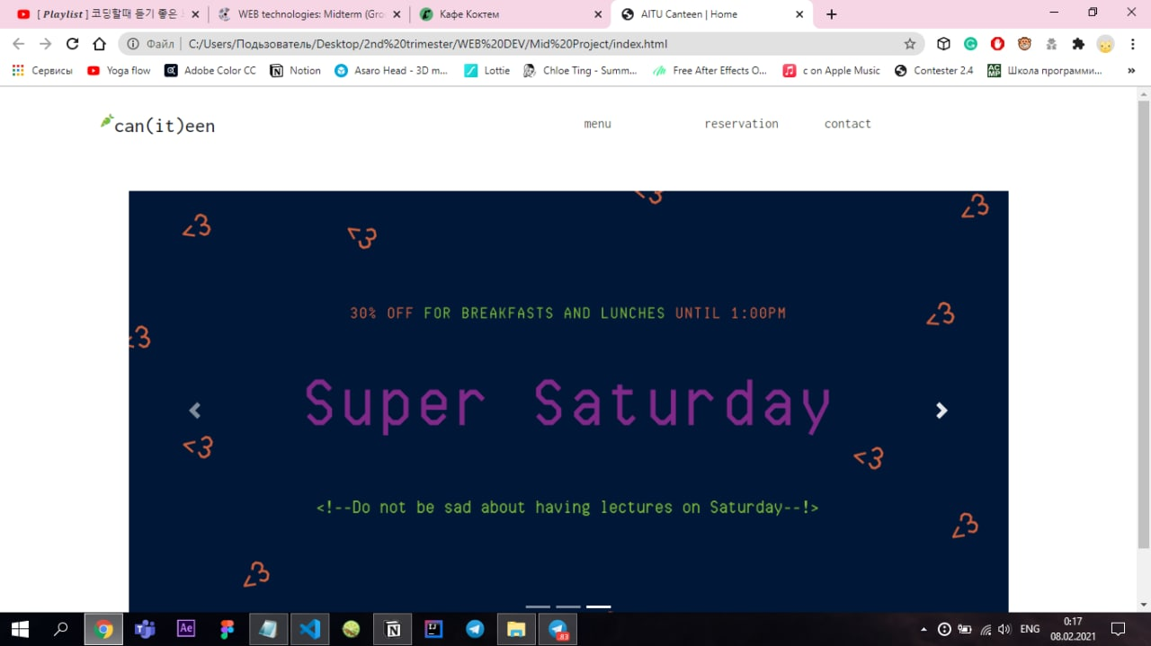

Navigation bar in homepage

*Figure 4.4.1.1 – homepage of the website.*

The figure above represents the homepage of the website. It can be clearly noticed that the homepage consists of the navigation bar. The navbar point out on several webpages further, such as menu, reservation and contact. By clicking on these, the website automatically will move to the webpages further. By this, it means that whenever you click on “menu”, the menu of the canteen will be displayed in the next webpage. Whenever the user click on reservation page, it will automatically switch to separate booking system respectively. The same happens to “contact” page when user clicks on it.

General guide:

1. The user need to click on the name of webpages in the navigation bar, depending on which webpage he user would like open in particular.

### **4.4.2 Menu**

### **4.4.2.1 Breakfast section**

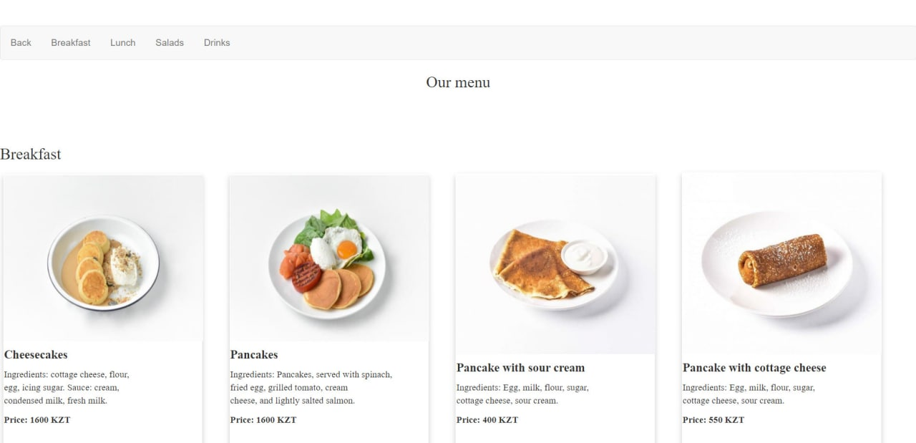

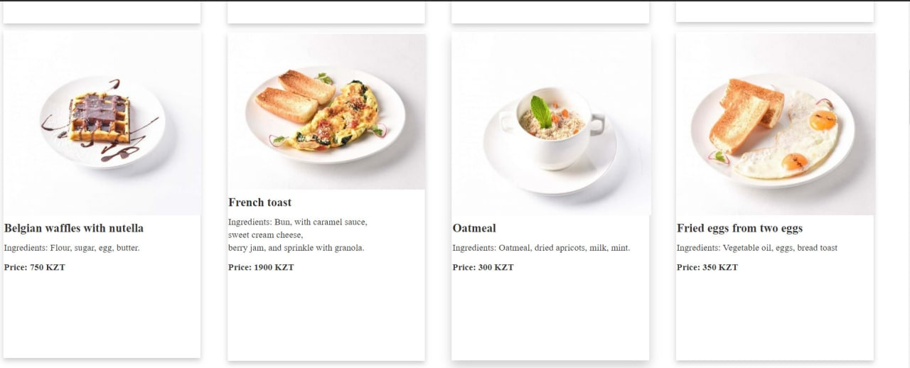

*Figure 4.4.2.1- the breakfast menu.*

The figure above illustrates the menu of a canteen in a breakfast section.

### **4.4.2.2 Salads section**

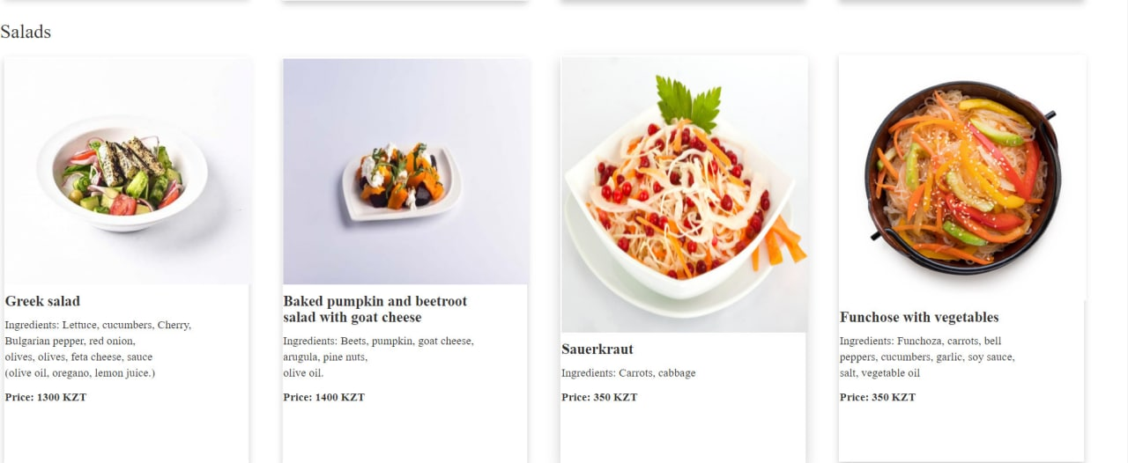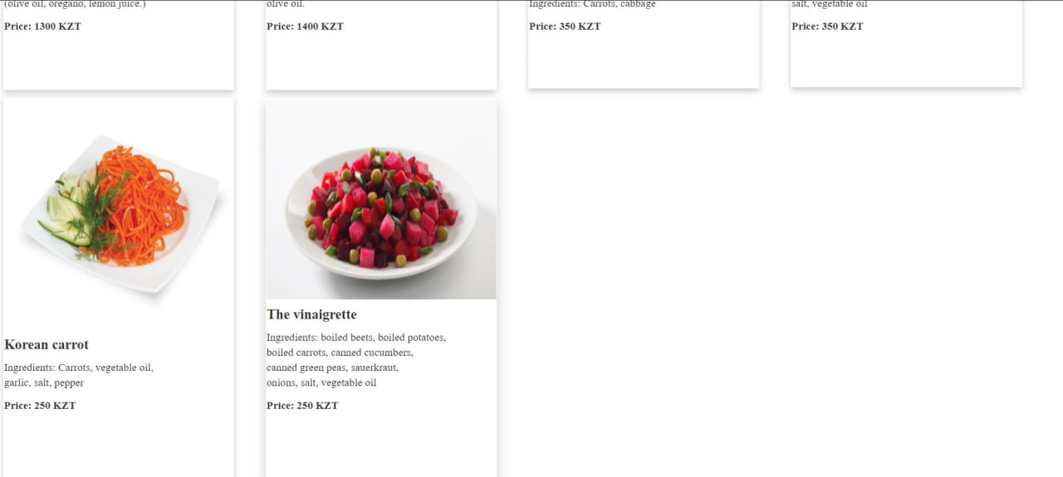

*Figure 4.4.2.2- the salad menu.*

The figure above illustrates the menu of a canteen in a salad section.

### **4.4.2.3 Lunch section**

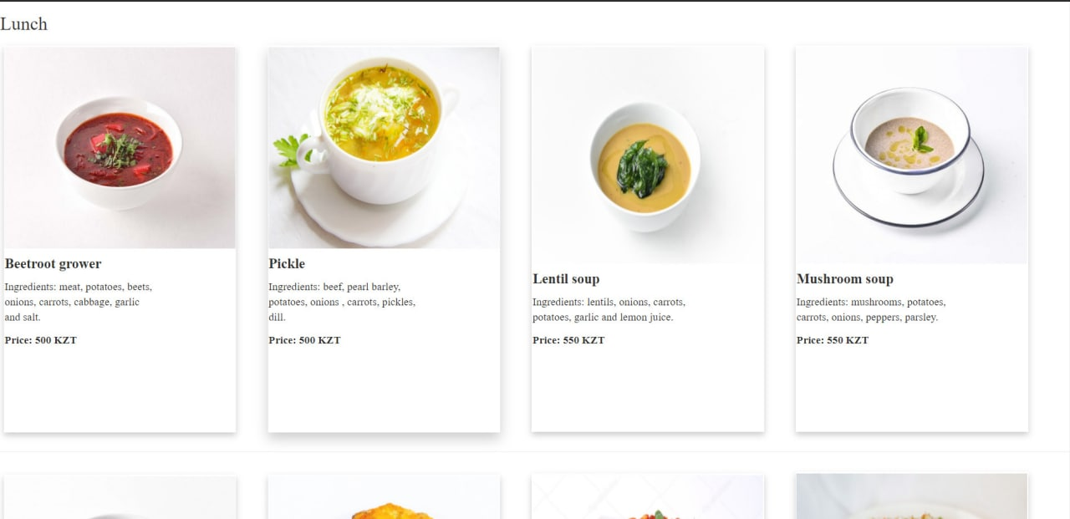

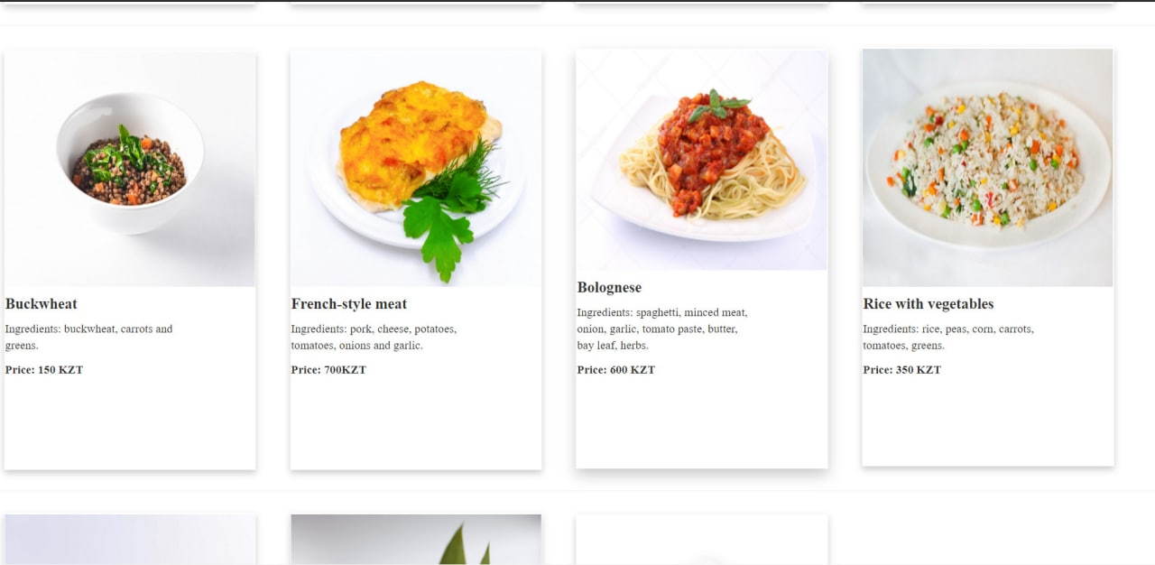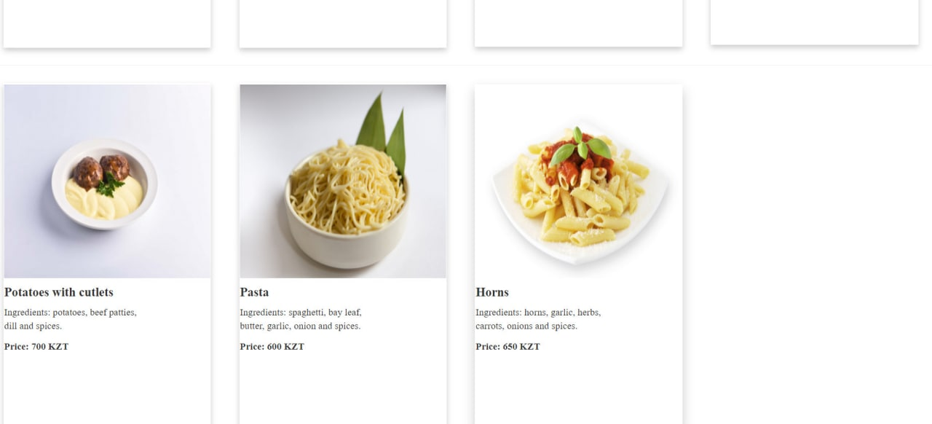

*Figure 4.4.2.3- the lunch menu.*

The figure above illustrates the menu of a canteen in a lunch section.

### **4.4.2.4 Drinks section**

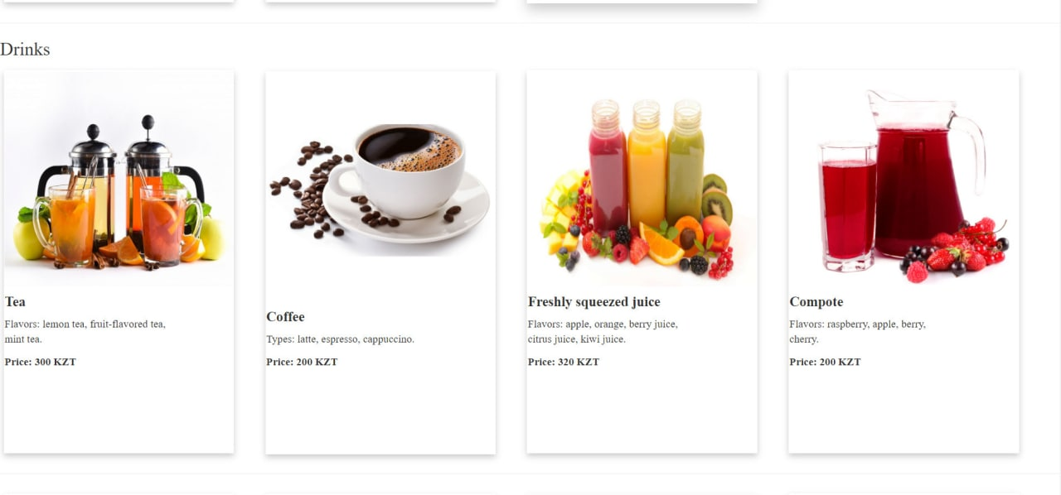 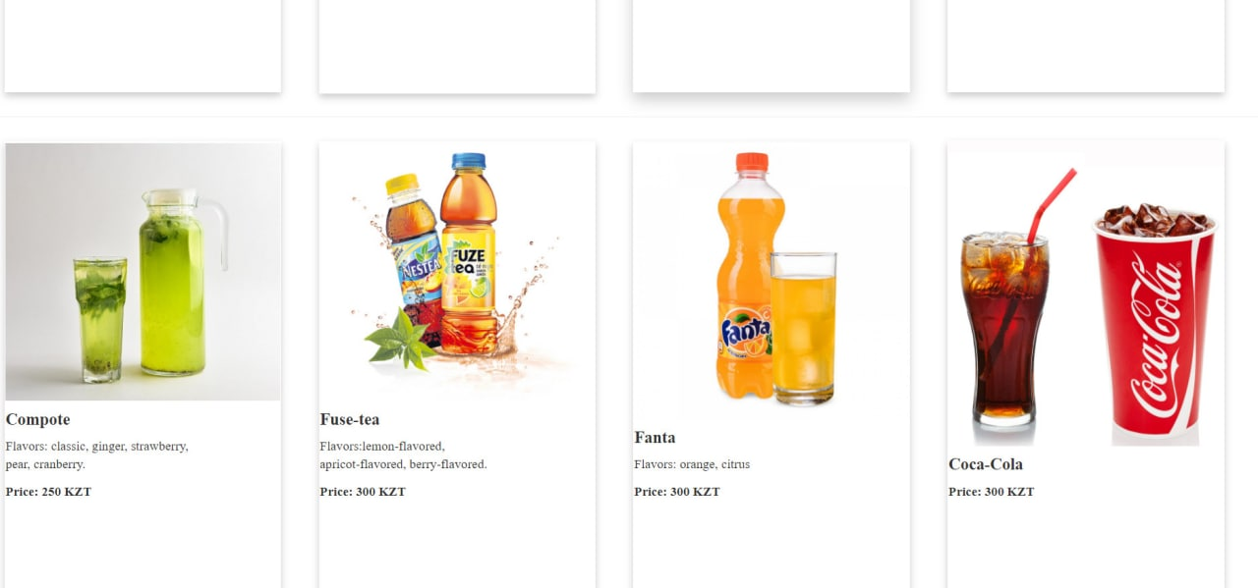

*Figure 4.4.2.4- the drinks menu.*

The figure above illustrates the menu of a canteen in a drinks section.

General guide:

1. Pick up appropriate section and look at the available food items.
2. Scroll down till the end.

### **4.4.3 Reservation**

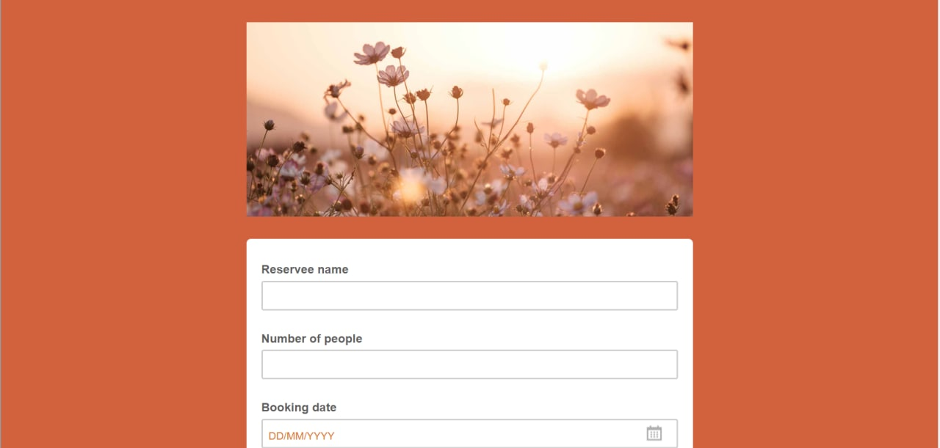

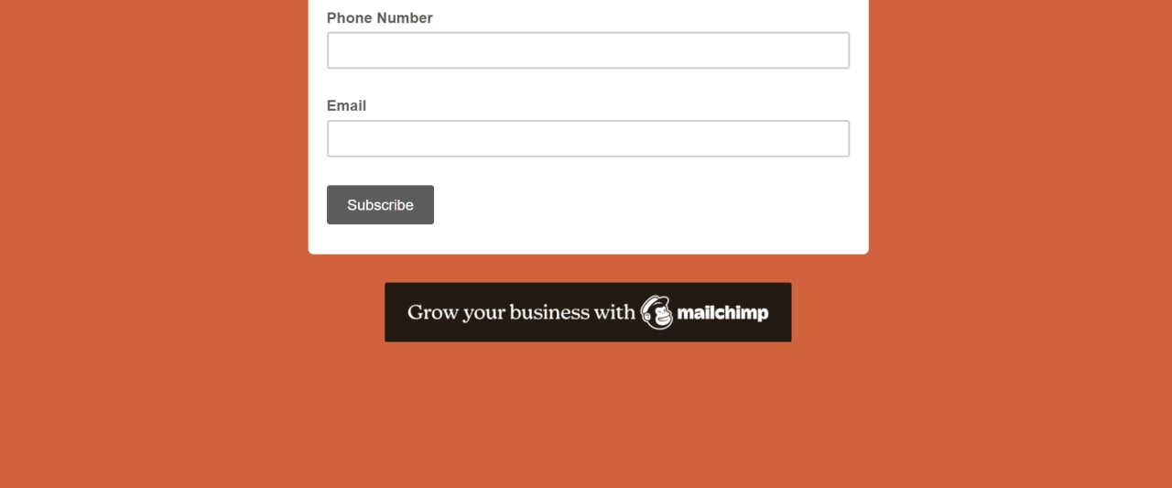

*Figure 4.4.3.1 –reservation form of the website.*

The figure above illustrates the booking form of the website which primary purpose of it is to book the place in a canteen. To reserve a place the user should input all required information, as long as the necessary information being retrieved, the place will be booked.

General guide:

1. Input reservee’s name.
2. Input number of people that would like to be on the same table.
3. Choose booking date from a calendar.
4. Input reservee’s phone number.
5. Insert email.
6. Click on button “subscribe”.

### **4.4.4 Contact**

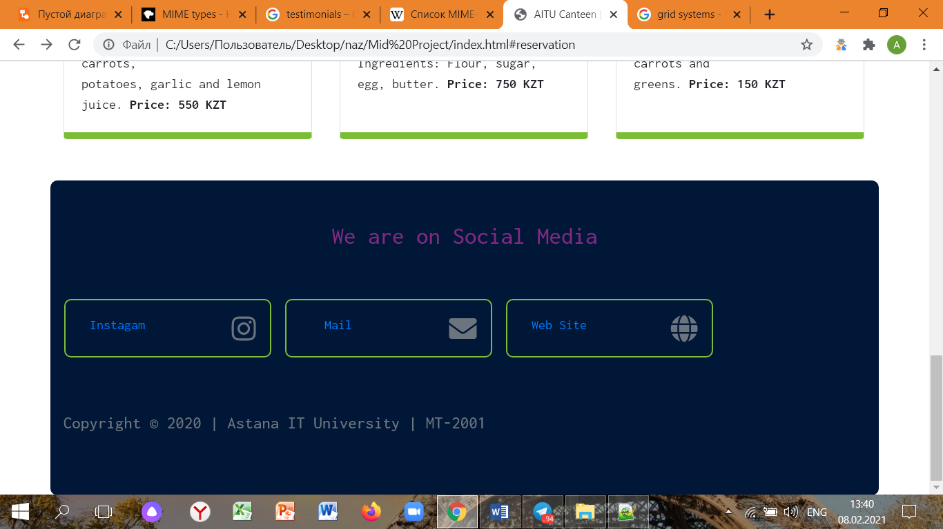

*Figure 4.4.4.1 – contact webpage.*

The figure above illustrates the contact information of the canteen. The information includes Instagram account profile, mail and the website itself.

General guide:

1. Click on “Instagram” if the user need to get an access to Instagram page.
2. The user can click on mail in case the user demands the email of the canteen.
3. The user can click on the website to move to the homepage of the site.

## **4.5 Hosting**

### **4.5.1 Software requirements**

|  |  |  |
| --- | --- | --- |
| Type: | Software: | Reason |
| Operating system | Windows | The Windows operating system is needed to work with programming languages, which will manage new system |
| Electronic database | MySQL/PostqreSQL | The MySQL is needed to store the entering by web-site pages |
| Server | XAMPP | The XAMPP program software is needed to implement MySQL and the web-site page |
| Program language | JS  HTML  CSS | The HTML, CSS are crucial to create good design structure |

### **4.5.2 Hardware requirements**

|  |  |  |
| --- | --- | --- |
| Type | Device | Function |
| Input hardware | Keyboard | Keyboard is necessary for input(entering) the indications and searching information |
| Mouse | Mouse is required to manage, when user gives commands (click button) |
| Output hardware | Monitor | Monitor is required to show the result of our task of the system. Necessary for displaying visual information to user |
| Storing | USB | USB is needed to store and transfer data |
| Hard drive disk | To store information permanently |
| RAM | RAM allows information to be stored and retrieved on a computer |
| Running the program | Internet modem | It runs a program since website does not work without the Internet |
| CPU | CPU is required for carrying out instructions of a computer program |

## **4.5.3 Technical specification (minimum specifics):**

* 2 GHz processor (supporting SSE2 instruction set or higher)
* 2 GB of RAM
* 8 GB available hard disk space
* Windows 7 or newer/ IOS 10 or higher
* Shader version 2.0 capable video card
* Screen resolutions up to 1920x1200
* Support for Direct X v9.0c or better

### **4.5.4 General guide of implementing GitHub**

To upload a project on a GitHub platform, following steps must be taken:

1. To click the following icon *(figure 4.5.4.1)* in the user’s homepage.

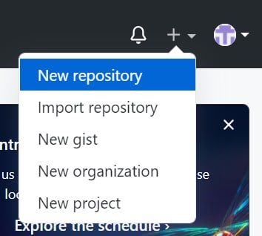

*Figure 4.5.4.1- the “plus” icon.*

The figure above demonstrates the icon which user have to click on in order to upload a project into the GitHub.

1. Click on “New repository”, after which the following form will be displayed *(figure 4.5.4.2)*

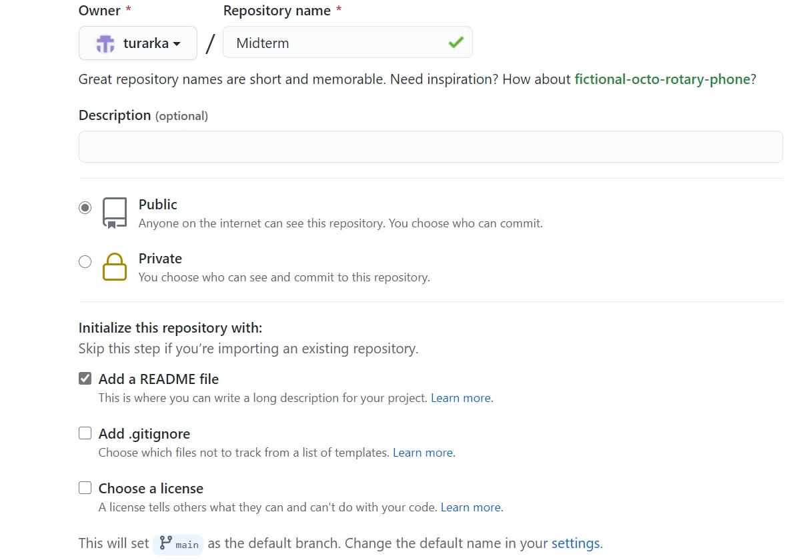

*Figure 4.5.4.2- the repository’s form.*

1. Select an owner of the project (on behalf of who the project is published).
2. Write down a name of the project.
3. The user can add the description, it is not mandatory to do so.
4. Choose what type of repository you would like to have (private or public). Public will be viewed by everyone, whereas the private one is restricted: the user choses who can view this project.
5. Tick an appropriate option which suits the user’s situation or skip this step if you import an existing repository.
6. After revising the information, ensuring that inputs are valid, submit the button “Create repository” (*figure 4.5.4.3*)

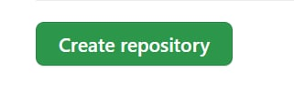

*Figure 4.5.4.3- the “Create repository” button.*

The figure above depicts the “Create repository” button after clicking which it will move to the next form *(figure 4.5.4.4).*

1. Click on “Add file” button *(figure 4.5.4.4)* and choose “Upload files” option.

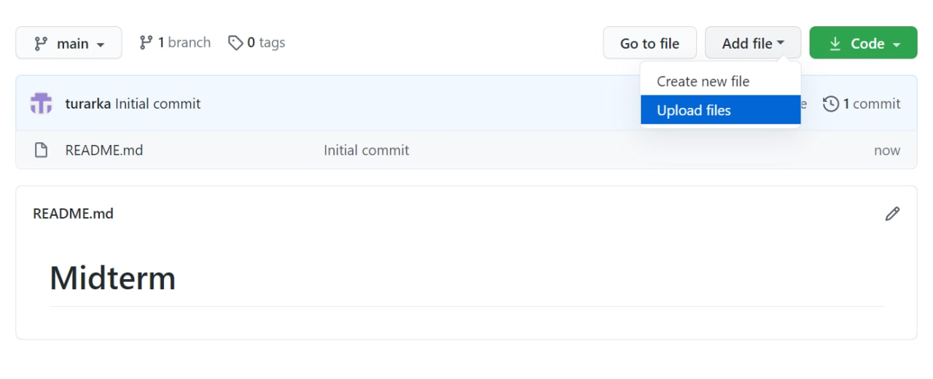

*Figure 4.5.4.4 – the uploading file form.*

The figure above illustrates the form where uploading of files is performed.

1. Select the source, which enables GitHub pages for this repository *(figure 4.5.4.5)* and select none when choosing branch.

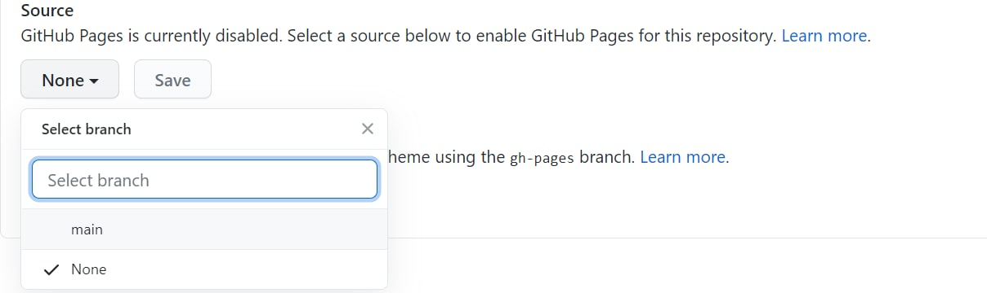

*Figure 4.5.4.5 source form.*

The figure above represents the source selection, necessary for uploading the project.

1. Selecting the branch and folder.

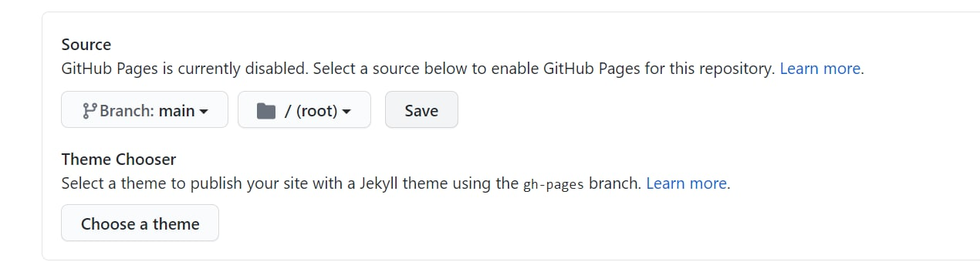

*Figure 4.5.4.5.1 the source form.*

The figure above depicts the source form where user selects the branch and folders.

1. Choose a theme for the project (optional).
2. Click button “Save”.

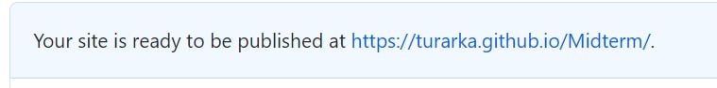

*Figure 4.5.4.6- the success notification.*

The figure above demonstrates that the uploading if files has been successfully performed.

## **4.6 Accessibility**

In order to prove that the project, created by “Garyshker” group is accessible, following arguments were supported by the images of the website:

1. The interface’s design is clear and convenient



*Figure 4.6.1- the homepage of the website.*

The image above justifies that the website has a convenient navigation bar.

1. The carousel with images of discount cards.

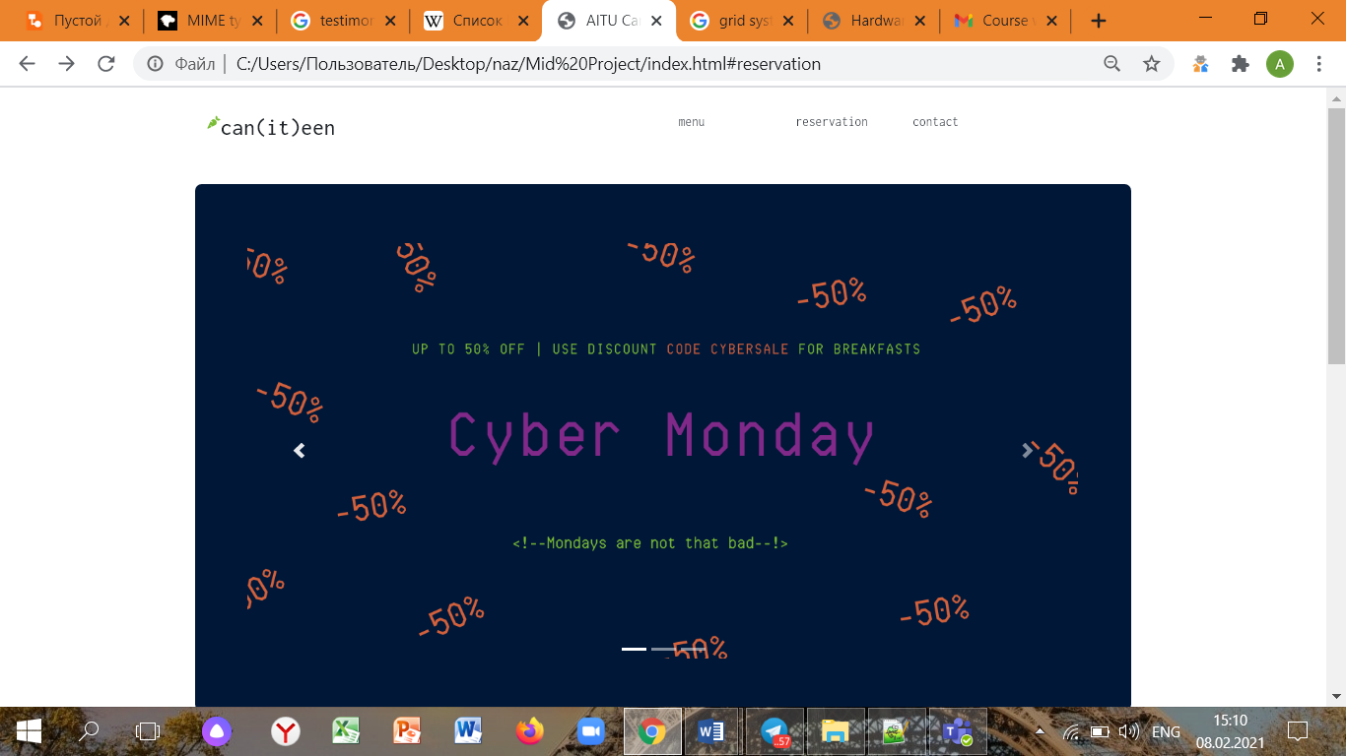

*Figure 4.6.2- the carousel of discounts in the homepage.*

The figure above shows the carousel of the pictures that was implemented by using <slide> tag. Although the colors were used are dark, the information is still readable as vivid colours were used.

1. Fonts are readable.

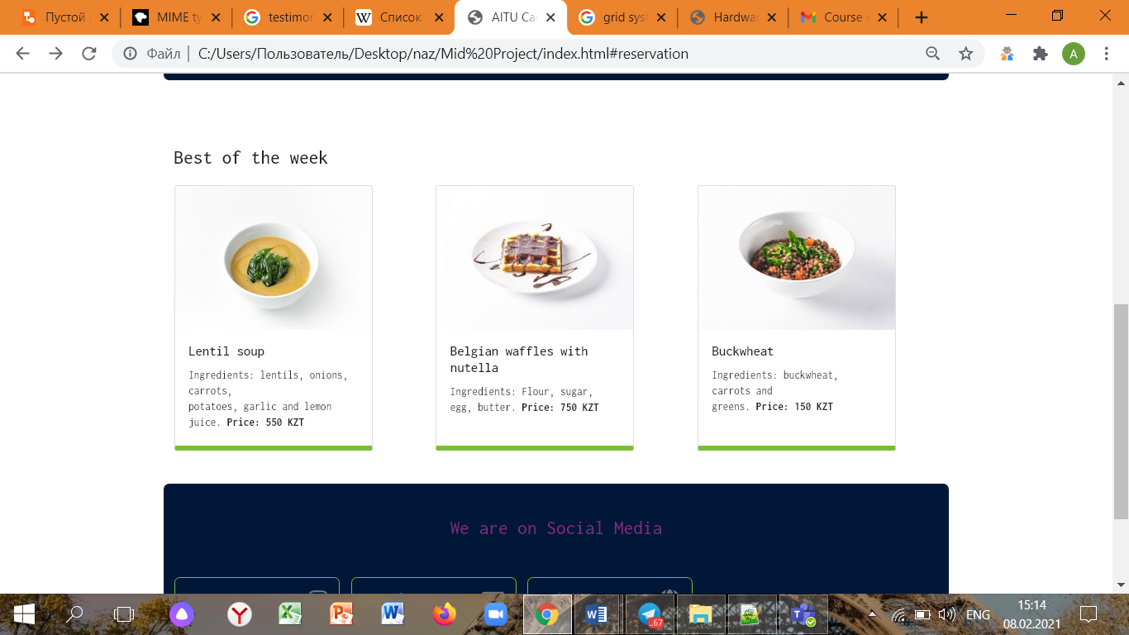

*Figure 4.6.3- the best dishes of the week in the homepage.*

The figure above proves that the fonts are readable and can be easily understanded.

1. Convenient button which hovers whenever the mouse is about to click on it.

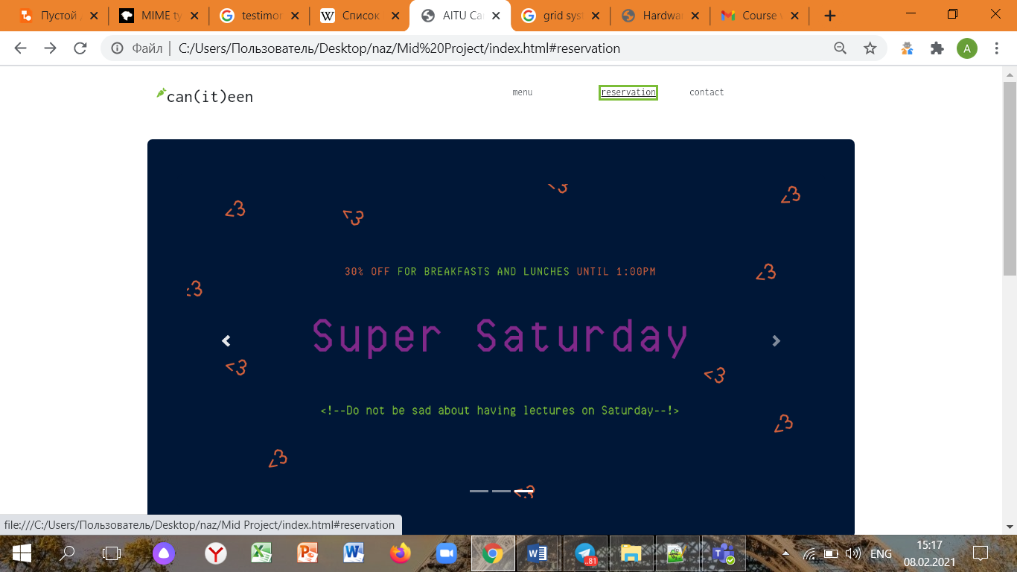

*Figure 4.6.4- hover state button.*

The figure above justifies that the buttons are hover state and convenient in usage.

1. Understandable contact information

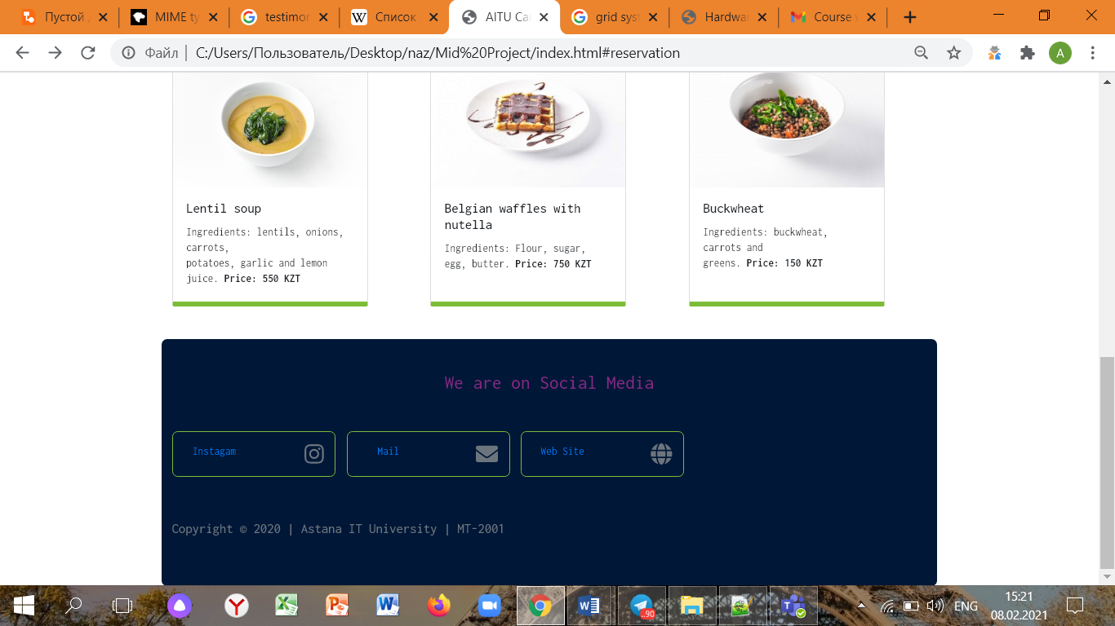

*Figure 4.6.5- the contact information.*

The figure above illustrates the contact information of the canteen, such as Instagram account, mail and the website itself.

1. Appealing and consequent placement of food items.

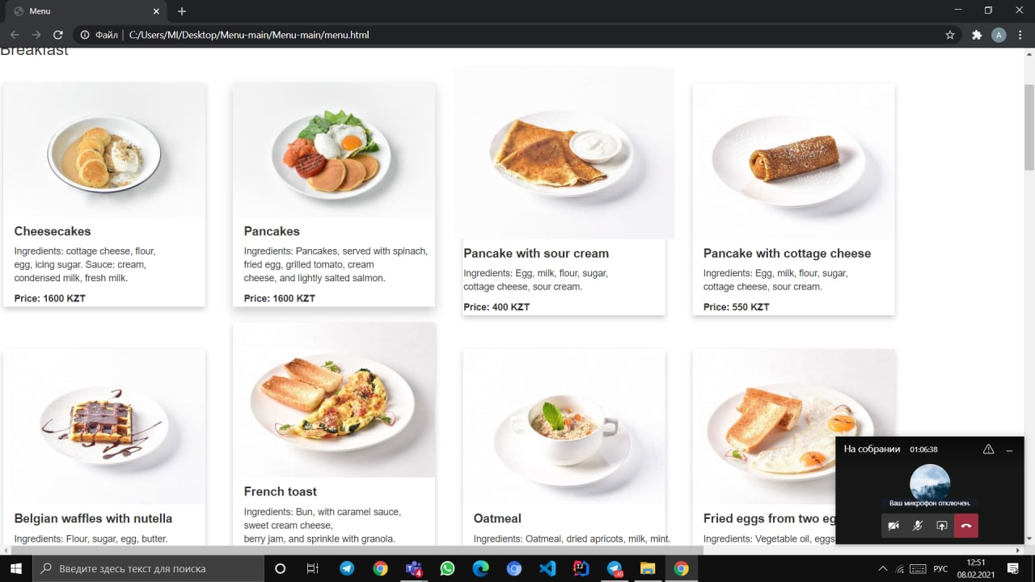

*Figure 4.6.6- the breakfast menu.*

The figure above confirms that food items follow logical order (breakfast dishes are only placed in “breakfast” section).

## **4.7 Deadlines**

In order to not to lag behind others, it was decided to set fixed deadlines. So that the group will not miss the deadlines and will not run out of schedule.

* Phase 1 – February 2, 23:00
* Phase 2 – February 3, 23:00
* Phase 3 – February 4, 23:00
* Phase 4 – February 5, 23:00
* Phase 5 – February 6, 23:00
* Phase 6 – February 6, 23:00
* Phase 7 – February 7, 23:00
* Phase 8 – February 8, 17:00

# **5. Summary**

The work that has been by our group is enormous, even voluminous. Each member of the group has acquired new skills that will be useful in further studying. Overall, the most crucial part of this project was to develop analytical skills, learn how to interact and negotiate with potential clients, and learn how to write and format research papers as well as to enhance HTML and CSS knowledge.

To conduct a detailed analysis of the new system, pros and cons of the project were determined. This allows us not only look at the advantages, but also flaws of the system in order to make a complex analysis from various perspectives.

*Intended benefits:*

* 1. Easy to implement. In comparison to the original system, entering data, editing, deleting and all other operations can be simply done on computerized versions. The consumer has to input data to text input in the forms and wait for the respond.
  2. Appealing design structure.
  3. Fast speed of operations. The new system can reduce the redundant processes in the original method and use programs to grow the speed of searching, entering data, checking and other operations. Thus, it can increase the efficiency of staff’s time.
  4. Constant backups. Since the project is stored in the single folder, it is easy to create its copies.

*Limitations:*

1. No data security since there is no connected database to localhost.
2. No sign in and sign up forms.
3. To create a shopping bag for food items.
4. To add a function of buying food items online and paying online as well.

*Future updates:*

1. Connect the website with database on MySQL/PostgreSQL.
2. Perform data security means, such encryption, password hashing, validation, 2-factor authentication, all of which could be easily organized by using JS/PHP.
3. Create sign in and sign up webpages.

*Faced challenges:*

1. Since we divided the webpages, it was extremely hard to collect all of the separate webpages into one whole website.

To conclude, this midterm project work has boosted the skills of each member tremendously. We have consolidated not only theoretical knowledge, but also used it in practice. Furthermore, we have developed our skills in creating sophisticated websites by using advanced CSS and Bootstrap; and more importantly, supplying a client with reasonable solutions in tight deadlines. Moreover, this project gave us an opportunity to improve our negotiation skills as we were interacting with ourselves and learned to look at the issue from various perspectives. In addition, learning how to arrange the research paper is worth mentioning separately as we genuinely believe that these aforementioned skills would be useful, especially while conducting diploma work.

# **6. References**

1. W3 schools, HTML tags.

Retrieved from: <https://www.w3schools.com/html/>

2. W3 schools, CSS.

Retrieved from: https://www.w3schools.com/css/default.asp

3. W3 schools, Bootstrap

Retrieved from: <https://www.w3schools.com/bootstrap/>

1. Web Development Tutorials, Create responsive Bootstrap 4 cards

Retrieved from: <https://www.youtube.com/watch?v=yzRgUUFSGOs&ab_channel=WebDevelopmentTutorials>